**Kafka Installation Doc**

So, for mac users

First delete existing Kafka entries by following below steps.

**Remove Previous Version**

* Go to your kafka folder using command line and start zookeeper using command

**bin/zookeeper-server-start.sh config/zookeeper.properties**

* Now open one more terminal in the same location and run

**bin/kafka-server-start.sh config/server.properties**

* Now open one more terminal at the same location and run

**bin/kafka-topics.sh --zookeeper localhost:2181 --delete --topic test**

**bin/kafka-topics.sh --zookeeper localhost:2181 --delete --topic response_topic**

**bin/kafka-topics.sh --zookeeper localhost:2181 --delete --topic post_book**

* To check if all the topics are deleted run

**bin/kafka-topics.sh --list --zookeeper localhost:2181**

* **This should return blank. If it returns topic_name –-mark for deletion then you will have to wait till it disappears.**
* **Once deletion is successful and no topic is listed**

**Terminate kafka ctrl+c by running in kafka window**

**Terminate zookeeper ctrl+c by running in zookeeper window**

* **Run lsof -i tcp:2181 in any new command line terminal**

**If you see any pid listed just delete those pids using**

**kill -9 pid(this will be pid number)**

**Example: kill -9 8171**

* **Now delete the entire kafka folder from your computer by doing move to trash.**
* **Delete any older kafka code that you have and terminate any kafka node servers if you are running any.**

**Now let’s start from fresh**

* **Download Kafka-Stable.zip**
* **It contains two zip files**

**kafka_2.11-1.1.0.zip and kafka.zip**

* **Unzip both the files.**
* **Open new terminal and get into kafka_2.11-1.1.0 folder using command line terminal and run**

**bin/zookeeper-server-start.sh config/zookeeper.properties**

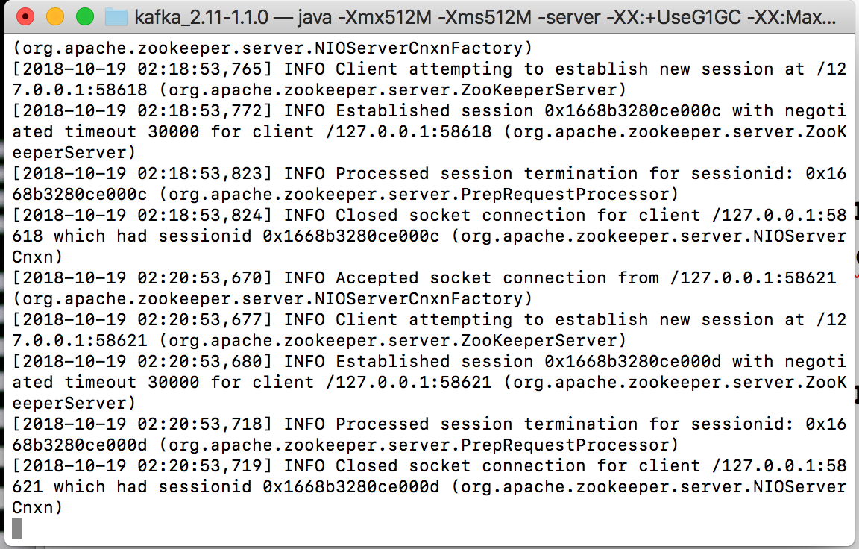

* **Now open new terminal at the same location and run**

**bin/kafka-server-start.sh config/server.properties**

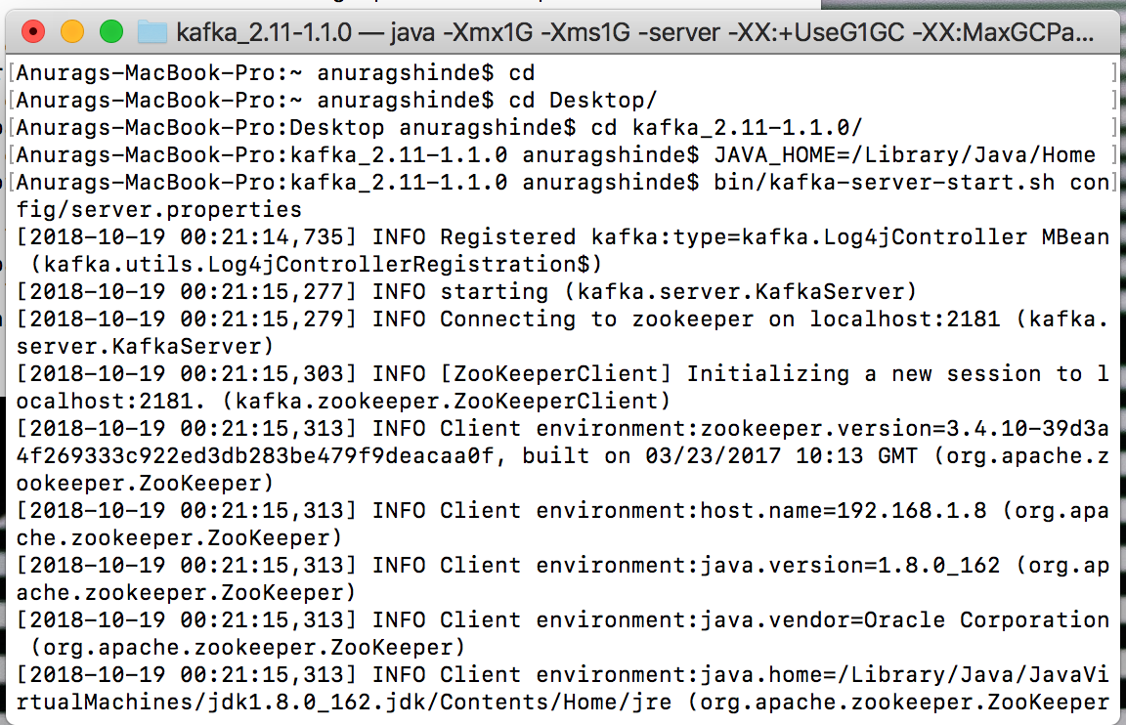

* **Now open new terminal at the same location and run**

1. **bin/kafka-topics.sh --create --zookeeper localhost:2181 --replication-factor 1 --partitions 1 --topic post_book**
2. **bin/kafka-topics.sh --create --zookeeper localhost:2181 --replication-factor 1 --partitions 1 --topic response_topic**

**If you get topic already exist error, then follow deletion steps properly.**

* **Now run**

**bin/kafka-topics.sh --list --zookeeper localhost:2181**



* **Now** Open new terminal,

Go to kafka (code) folder and go inside Backend folder using command line terminal

Run command : node index.js

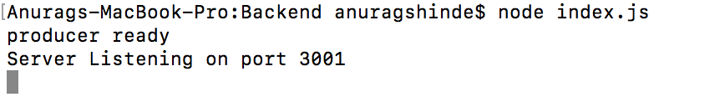

* **Now open new terminal**

Go to kafka (code) folder and go inside kafka-backend folder using command line terminal

Run command: npm start

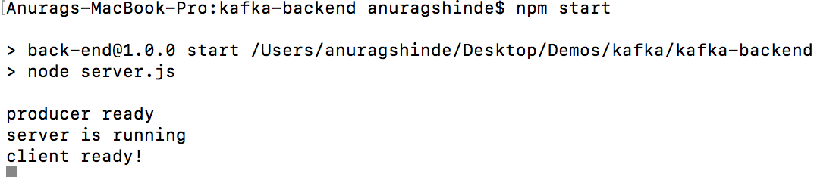

* Now open Postman enter the following details

{

"BookID" : "122",

"Title" : "Book 122",

"Author" : "Author 122"

}

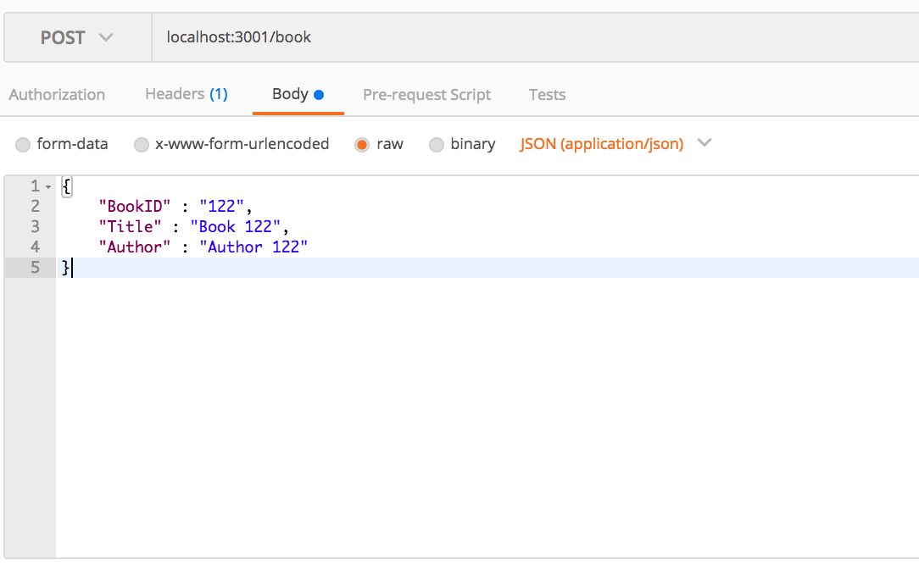

Use **JSON(application/json)** not text see the screenshot above.

* Click on send and you should be able to get below response.

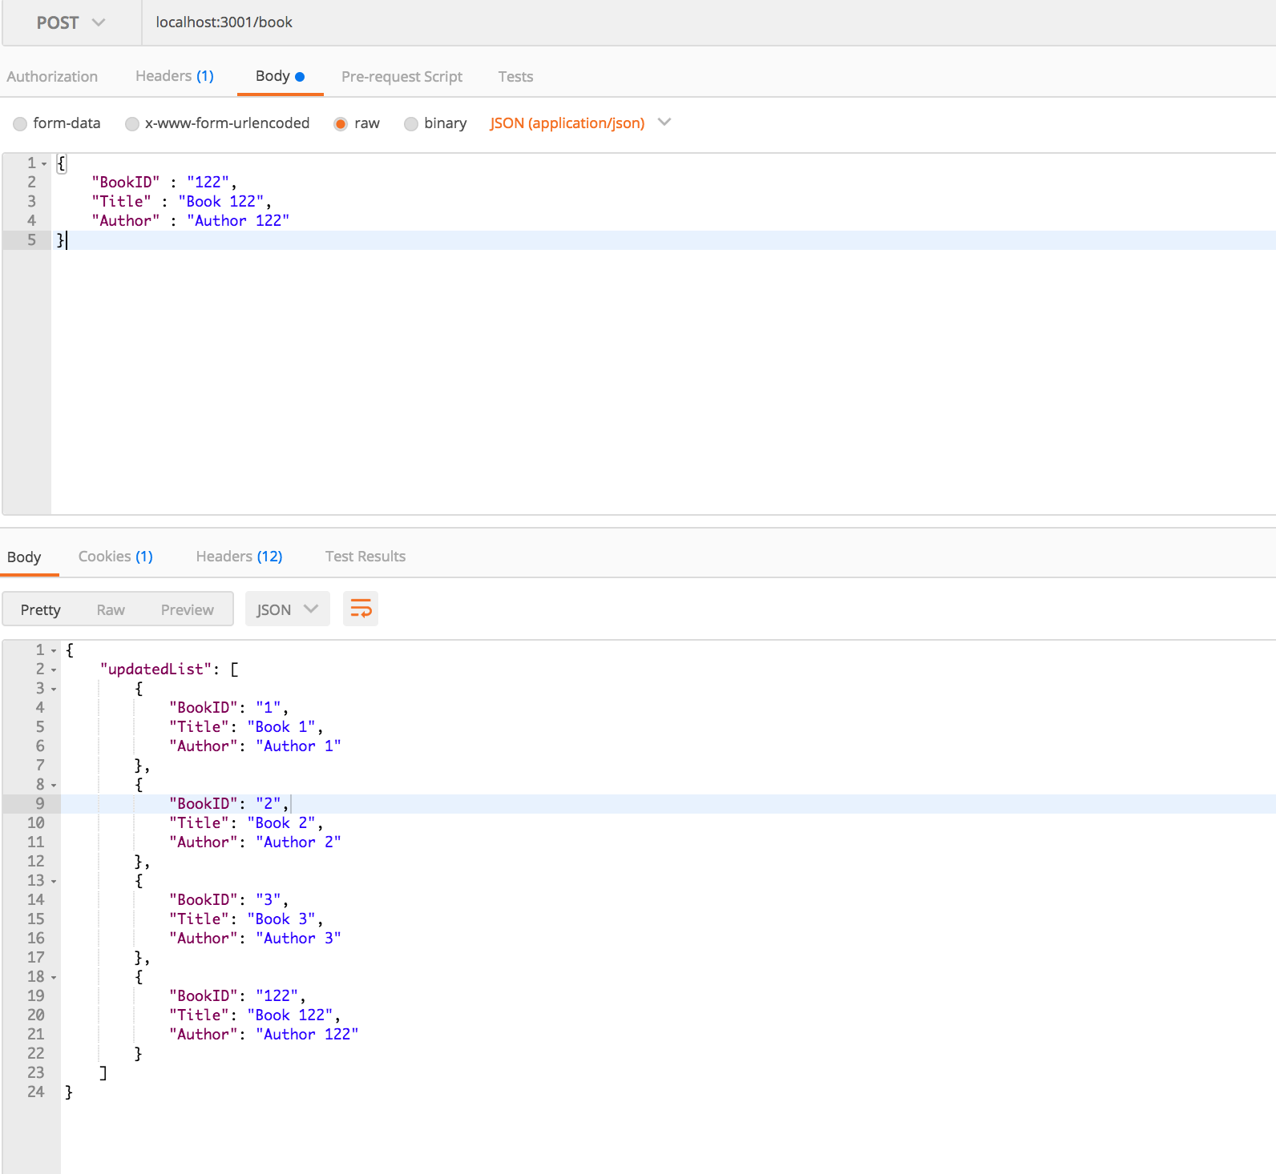

* For windows users

Install git bash and then you can use the above commands.

You will also have to download **kafka_2.11-1.1.0 for windows. Hope it works for you but you face any difficulties please let us know. Rajiv will be your primary point of contact.**